

**ARTIFICIAL INTELLIGENCE**

**IN**

**SURGERY**

|  |  |  |
| --- | --- | --- |
| **S.NO** | **NAME** | **ROLL NO** |
| 1. | Mullapudi Mahesh Sai | CB.EN.U4CSE20143 |
| 2. | Katheram Venkata Sai Ram Reddy | CB.EN.U4CSE20131 |
| 3. | Yarra Jagadish Kumar | CB.EN.U4CSE20171 |
| 4. | Ravneet Singh | CB.EN.U4CSE20651 |

**INTRODUCTION**

Artificial intelligence (AI), printed as algorithms that alter machines to perform psychological feature functions has changed for some time presently the face of health care through machine learning (ML) and tongue method (NLP).

Its use in surgery, however, took a longer time than in different medical specialties, primarily because of missing data concerning the probabilities of machine implementation in wise surgery. owing to fast developments registered, AI is presently perceived as a supplement and not a replacement for the power of somebody's MD.

And though the potential of the surgeon-patient-computer relationship may be a good distance from being altogether explored, the utilization of AI in surgery is already driving important changes for doctors and patients alike.

For example, surgical arising with and navigation have improved consistently through X-radiation , ultrasound and resonance imaging whereas minimally invasive surgery.

In this article, we have a tendency to review the applications of AI in pre-operative designing, intraoperative steerage, furthermore as its integrated use in surgical AI. in style AI techniques as well as a summary of their necessities, challenges and subareas in surgery are printed.

**MOTIVATION**

Surgery is one amongst the foremost crucial areas within the field of drugs and has been performed for hundreds of years. Being one amongst the foremost common and effective strategies of treatment, surgery comes with numerous complications.

A recent study calculated that 7-15% of patients United Nations agency bear surgery face surgical complications that vary from non-significant to fatal outcomes.

Healthcare facilities have more and more adopted AI and robotic technology, as well as the employment of surgical robots

AI-assisted identification of the initial drawback and ensuing surgical website location isn't solely simplifying procedures however, in some cases, reducing or eliminating the necessity for surgery within the first place.

Artificial intelligence (AI) has recently achieved considerable success in domains such as object detection, speech recognition, or natural language processing. Recently, several success stories have been published in the medical domain based on DL for image classification, such as prediction of cardiovascular risk based on retinal images, skin lesion classification, or breast cancer detection based on mammograms.

**ROLE OF AI IN SURGERY**

The use of AI in surgery has taken slightly longer to develop than other medical specialties, due to limited understanding of the surgeon-patient-computer relationship. However, recent technological advancements have demonstrated how further AI developments will be invaluable to improving surgical planning and navigation.

Artificial intelligence (AI) has the potential to play a significant role in surgery and has already been applied in various ways in the field.

**Planning and simulation:** AI algorithms can be used to create virtual models of a patient's anatomy and simulate different surgical approaches, helping surgeons to plan and prepare for the procedure.

**Image analysis:** AI can be used to analyze medical images, such as CT scans or MRI scans, and identify abnormalities or areas of interest. This can help surgeons to make more accurate diagnoses and treatment plans.

**Robotic assistance:** Surgical robots equipped with AI can be used to assist surgeons in performing procedures. These robots can be programmed to perform precise movements, allowing the surgeon to operate with greater precision and control.

**Decision support:** AI can be used to analyze data from a patient's medical history and current condition to provide recommendations or suggestions for treatment options. This can help surgeons to make more informed decisions and improve patient outcomes.

**Training and education:** AI can be used to create virtual training environments for surgeons, allowing them to practice and hone their skills without the need for live patients or cadavers.

**Backpropagation:** For each input given to the network, it makes a prediction of the desired output. The error of that prediction is calculated with respect to the expected output, and the weights are adjusted to minimize the error. As a result, the accuracy and success percentage of surgery will be improved.

Overall, the use of AI in surgery has the potential to improve accuracy, efficiency, and patient outcomes. However, it is important for the development and implementation of AI in surgery to be guided by ethical considerations and a commitment to patient safety.

**EXISTING METHODS**

There are mainly three existing methods

1.Preoperative planning

2.Intra-operative planning

3.Surgical robotics

Preoperative and intraoperative are used in either supervised or unsupervised learning-based techniques for various surgical applications

**Preoperative planning:**

Preoperative planning is the process of preparing for a surgical procedure, including determining the appropriate surgical approach, identifying any potential risks or complications, and developing a plan to manage those risks.

Among existing imaging modalities, X-ray, CT, ultrasound and MRI are the most common ones used in practice

Routine tasks based on medical imaging include anatomical classification, detection, segmentation, and registration.

**1.Classification**: Classification can involve using various diagnostic tests and imaging studies to determine the nature and extent of the patient's condition. For example, a surgeon may use classification techniques to determine the type and stage of a cancerous tumor, or to diagnose a congenital heart defect.

**2.Detection**: Detection involves identifying the presence or absence of a specific condition or structure in the patient's anatomy. This can be done using a variety of techniques, such as imaging studies or biopsy, and can help the surgeon to plan the surgical approach and determine the best course of treatment.

**3.Segmentation**: Segmentation involves dividing the patient's anatomy into distinct regions or structures, using techniques such as imaging studies or computer algorithms. This can be useful for identifying specific structures or areas that need to be addressed during the surgery, such as a tumor or damaged tissue.

**4.Registration**: Registration involves aligning or overlaying different images or data sets to create a comprehensive view of the patient's anatomy. This can be done using various techniques, such as CT or MRI scans, and can help the surgeon to plan the surgical approach and determine the best course of treatment.

**Intra operative planning:**

Intraoperative planning refers to the process of adapting and adjusting the surgical plan during the actual procedure. It involves evaluating the patient's condition, identifying any potential complications or challenges that may arise during the surgery, and determining the best course of action to achieve the desired surgical outcome.

For the purpose of intraoperative guidance, recent work can be divided into four main aspects: intra-operative shape instantiation, endoscopic navigation, tissue tracking and Augmented Reality.

**1. Shape instantiation**:

Intra-operative shape instantiation refers to the use of computer-assisted techniques to create a 3D model of a patient's anatomy during a surgical procedure. This can be done using imaging studies, such as CT or MRI scans, or by using sensors and cameras to capture real-time data during the surgery. The resulting 3D model can be used to aid in surgical planning and navigation, as well as to guide the placement of implants or other medical devices.

**2. Endoscopic Navigation**: Endoscopic navigation is a technique that uses a small, flexible camera called an endoscope to visualize the inside of a patient's body during surgery. The endoscope is inserted through a small incision or natural opening, such as the mouth or nose, and can provide high-resolution images of the surgical site. Endoscopic navigation can be used to guide the surgeon during minimally invasive procedures, such as laparoscopic surgery, and can reduce the need for larger incisions and scarring.

**3.Tissue Tracking**: Tissue tracking is a technology that uses sensors or imaging techniques to track the movement of tissue during a surgical procedure. This can be useful for identifying and correcting any errors or deviations from the surgical plan, as well as for assessing the effect of the surgery on surrounding tissues.

**4. Augmented Reality**: AR can be used to provide the surgeon with additional information or guidance during the procedure. For example, AR may be used to display the location of blood vessels or other structures that are not visible to the naked eye, or to provide instructions for the placement of medical devices.AR improves surgeons’ intraoperative vision through a prevision of a semi-transparent overlay of pre-operative imaging on the area of interest.

**Surgical Robotics:**

A surgical robot is a machine that is used to assist surgeons in performing procedures. Surgical robots are equipped with a variety of instruments controlled by the surgeon using a console.

The objective of AI is to boost the capability of surgical robotic systems in perceiving the complex in vivo environment, conducting decision making, and performing the desired task with increased precision, safety, and efficiency common AI techniques used for Robotic and Autonomous Systems (RAS) can be summarized in the following three aspects:

1) perception

2) system modeling and control, and

3) human-robot interaction

**1) Perception**:

In surgical applications, autonomous systems may use sensors and imaging technologies to gather information about the patient's anatomy and the surgical environment. This includes data about the location and orientation of tissues, vessels, and other structures, as well as the movements of the surgical instruments and the surgeon.

**2. System Modelling and Control:** Surgical robots in surgery use this information to build models of the surgical environment and to determine the best course of action to achieve their goals. This may involve using algorithms or other methods to process and analyze the data, and to control the system's movements and actions.

Learning from demonstration (LfD) is a popular paradigm for enabling robots to autonomously perform new tasks with the learned policies. LfD is to first segment a complicated surgical task into several motion primitives or subtasks, followed by recognition, modeling and execution of these motion primitives sequentially

**3. Human-Robot Interaction:** In many surgical applications, Surgical robots must be able to interact with the surgeon in a safe and effective manner. This may involve using user interfaces and other methods of communication to allow the surgeon to input instructions or other information to the system, and to monitor its progress. It may also involve using sensors and other technologies to detect the presence and actions of the surgical team.

With the development of deep learning in speech recognition, the precision and the accuracy of speech recognition have been significantly improved. This improvement leads to a more reliable control of the surgical robot.

**Artificial intelligence in orthopedics**

The incorporation of technology into everyday medical practice is accelerating at an incredible rate — in few areas more so than in the domain of orthopedic surgery. Real-time navigated, computer-guided and robot assisted intraoperative input has become commonplace in many regions. Two-dimensional imaging is rapidly being replaced by virtual three-dimensional (3D) displays, and interactive digital, semi-automated or fully-automated preoperative planning and templating are also widely available in many developed settings.

Computer vision associated with deep learning, especially convolutional neural networks (CNN), is more widely used than conventional machine learning algorithms due to improved performance. A CNN is a multi-layer network constituted of

(1) convolutional layer,

(2) pooling layer, and

(3) fully connected layer.

Convolutional and pooling layers are used for feature extraction and dimension reduction, respectively. The fully connected layer receives a reduced feature map from the aforementioned layers and provides the final outcome of interest.

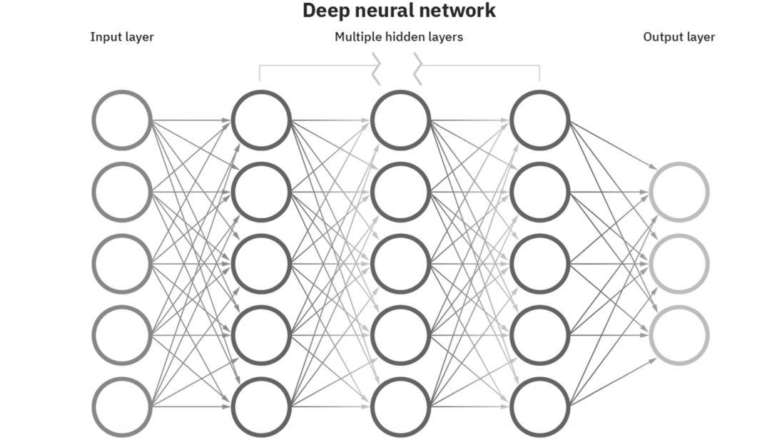

There are three main strategies for addressing computer vision problems with deep learning:

(1) classification,

(2) object detection,

(3) segmentation

**Classification:**

ResNet is one of the most well-known and recognized classification neural networks. A classification network is commonly used to assess the presence of abnormalities, classify the type of abnormality, or grade the severity. The labeling process of the classification network is the easiest among the three strategies, as only the class of each image needs to be labeled.

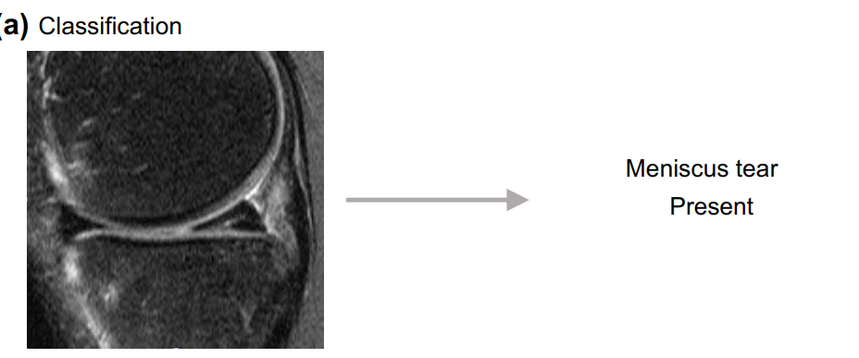

**Object detection**:

The most widely known object detection neural network is YOLO (You Only Look Once). YOLO annotates a target object by a bounding box and reports the category the target object belongs to. As inferred by its name, the YOLO network works rapidly, allowing real-time analysis of images and videos.

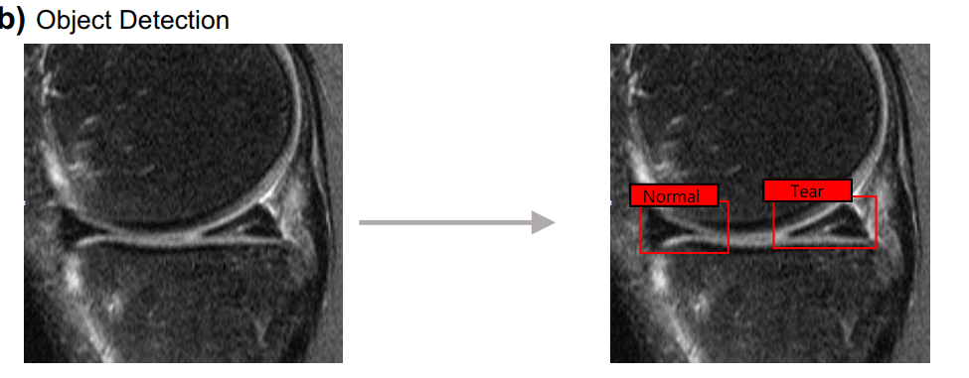

**Segmentation:**

U-net is one of the most powerful and established segmentation neural networks. A segmentation network reports the exact pixel-wise probability of the presence of the target object. However, to train the network, pixel-wise annotation of train images is required, which can consume significant resources, and is both humanly and computationally expensive.

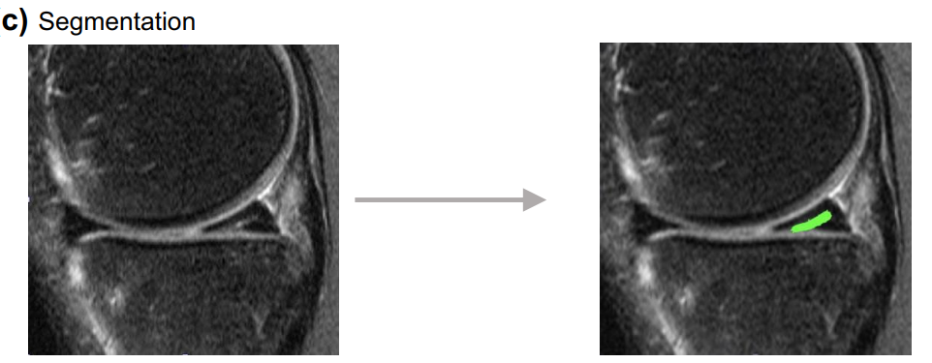

**Combination strategies:**

These three strategies are commonly used to address computer vision problems and achieve deep learning solutions in the orthopedic fled. Although introduced separately, they can also be used in combination with one another and often are. For example, Liu et al. used a segmentation network from a knee MR image to identify the cartilage region. The cartilage regions were cropped into a small square patch for the classification network to detect the cartilage lesion. Identification of cartilage area allowed the classification network to focus on cartilage area, yielding better performances.

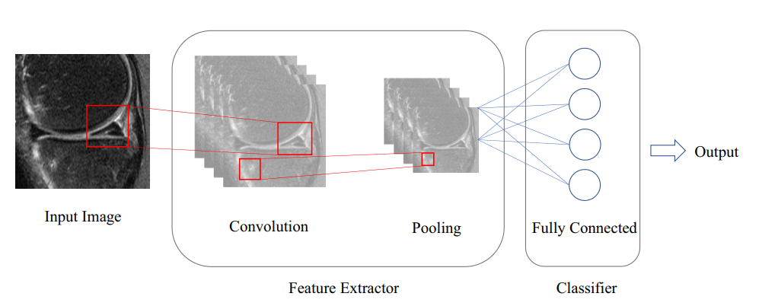

**LIMITATIONS**

As we explore the future possibilities of surgical intelligence augmented by AI, there are several limitations to the use of artificial intelligence (AI) in surgery:

**Lack of human intuition**: AI algorithms can analyze and process large amounts of data quickly, but they lack the intuition and creativity of a human surgeon.

**Dependence on data**: AI algorithms rely on data to learn and make decisions. If the data used to train the algorithm is limited or biased, the AI system may make incorrect or suboptimal decisions.

**Lack of flexibility**: AI algorithms are designed to perform specific tasks and may not be able to adapt to unexpected situations or changes during surgery.

**Ethical concerns**: There are concerns about the potential for AI to replace human surgeons, leading to job loss and a decrease in the role of human judgment in decision-making.

**Cost**: AI systems can be expensive to develop and maintain, and may not be accessible to all hospitals or surgeons.

Like in any other industry, AI eventually will permeate almost all aspects of the surgical practice, and several regulatory bodies will be dictating how hospitals and surgeons can utilize this type of technology. And because surgical AI is still nascent, it is difficult to predict the unique future rules and regulations regarding its utilization, but it can be anticipated that they will be exercised at different levels, such as federal and state medical boards and individual hospitals and societies.

Legal considerations also likely will play a major role in surgical AI, because large amounts of data acquisition, especially video data, are paramount for the scalability and sustainability of the use of AI in surgery; therefore, broad policies governing data acquisition, storage, sharing, and utilization should be designed and agreed by surgeons, lawmakers, ethicists, privacy officers, engineers, payers, insurers, and patients.

**CONCLUSION**

Artificial intelligence (AI) has the potential to transform the field of surgery by providing surgeons with new tools and techniques to improve patient outcomes and reduce the risk of complications. AI can be used in a variety of applications, including preoperative planning, intra-operative planning, and robotic assistance.

Preoperative planning involves using AI algorithms to analyze data about the patient's condition and the planned surgical procedure, in order to optimize the surgical approach and improve patient outcomes. Intra-operative planning involves using AI algorithms to analyze data about the patient's condition and the surgical procedure as it progresses, in order to identify any potential complications or challenges and to determine the best course of action.

Robotic assistance involves using AI algorithms to enable robots to assist with tasks such as suturing, tissue dissection, and instrument handling. Robotic systems can be programmed to use AI algorithms to analyze data about the patient's anatomy and the surgical environment, in order to make decisions and perform tasks independently.

Overall, the integration of AI into surgery has the potential to improve patient outcomes and reduce the risk of complications. However, it is important for these systems to be thoroughly tested and validated before they are used in clinical practice, and for surgeons to be trained in their use.